D04. QA Process & Automation Strategy
1. QA Objectives
- Quality goals: The main objective of this QA effort is to ensure that the core functionalities of the Wordpress blog operate correctly and consistently.
These include:
- Navigation and access to public pages
-Search functionality and content retrieval
-Viewing and interacting with posts
-Comment submission and moderation workflows
-Basic user authentication (login)
-Role-based access and moderation behavior
A key secondary objective is the verification of role-based access control (RBAC) to ensure that permissions are applied correctly across different user roles (Admin, Author, Subscriber)
Additionally, the QA effort includes validation of:
-API availability and data exposure
-Data integrity for comment storage
-System behavior under edge scenarios (e.g. no search results)
- Release confidence goals:
Before any release, the team aims to ensure that:
- Core user-facing features are working as expected
- Admin actions (like managing comments or content) can be completed without issues
- Previously working functionality remains stable
- API endpoints return valid and secure responses
- The system behaves consistently across supported environment
2. Test Approach
Test Design Techniques
The primary test design technique used in this project is Black-box testing, where the system is validated based on inputs and expected outputs without knowledge of internal implementation.
Test scenarios focus on:
- Navigation behavior
- Search functionality
- Content access
- API responses
- Comment workflows
In addition, elements of Experience-based testing are applied, particularly in exploratory scenarios such as:
- No results search behavior
- API user visibility checks
- Role-based moderation behavior
- Test levels:
- Smoke testing:
Basic validation of critical functionality: Homepage loads correctly, Navigation works, Search returns expected results, Post pages open correctly, API endpoints respond (e.g. /posts)
- Sanity testing:
Quick checks after small changes: Navigation and links, Search behavior, Comment functionality, Basic database consistency (after fixes and updates)
- Regression testing:
Re-testing the main functionalities from D03 (login, search, posts, comments, Role-based behavior)
- UAT support:
Ensuring that the system meets expected user behavior and usability standards.
- Exploratory/Investigation Testing:
Focused on: Role-permission inconsistencies, API data exposure, Edge cases (e.g. empty search results

- Test types:
- Functional testing
Validation of: Navigation and page access, Search functionality, Post viewing and interaction, comment submission and moderation
- API testing
Validation of Wordpress Rest API endpoints: /posts (content availability), /users (user visibility and access control)

- Security / Access Control Testing
Validation of: Login behavior, Role-based permissions, Restricted visibility of user (Subscribers), Moderation permissions between Admin and Author roles.
- Role Permission Analysis:
Testing revealed that Post Ownership may override system hierarchy, meaning that Authors may have moderation capabilities within their own posts. This behaviour has been identified as a potential business risk and documented accordingly.

- Database integrity Testing
Validation that: Comments are stored correctly in the wp_comments table,
Data consistency is maintained after user actions
- Recovery / Maintenance Testing
Validation of system behavior in recovery scenarios: Database repair operations (MyISAM table repair)
- Responsive /Compatibility Testing
Basic validation of layout and usability across: Desktop, Mobile devices

- Entry criteria:
- The website is up and running
- Test data is available (users, posts, comments)
- User roles are properly configured (Admin, Author, Subscriber)
- REST API is accessible
- Database access is available when needed
- Media synchronization (uploads folder) is completed across environments

- Exit criteria:
- All critical test scenarios have been executed
- No critical issues remain
- Core flows (user and admin) are working properly
- API responses are validated
- Key data integrity checks are completed
- Residual risks are documented in the Risk List (D11).

3. Automation Strategy
- Automation goals:
- Reduce manual testing effort
- Increase repeatability and consistency
- Improve confidence in regression testing

API Validation: Manual testing of /users endpoint using Postman confirmed Status: 200OK, ensuring readiness for future automation.

Cross-Browser Validation: Platform compatibility was verified across Chrome and Firefox using automated Selenium tests.

Role-Based Regression Testing: Automated tests were implemented to validate access control for different user roles ( Admin, Author, Subscriber)

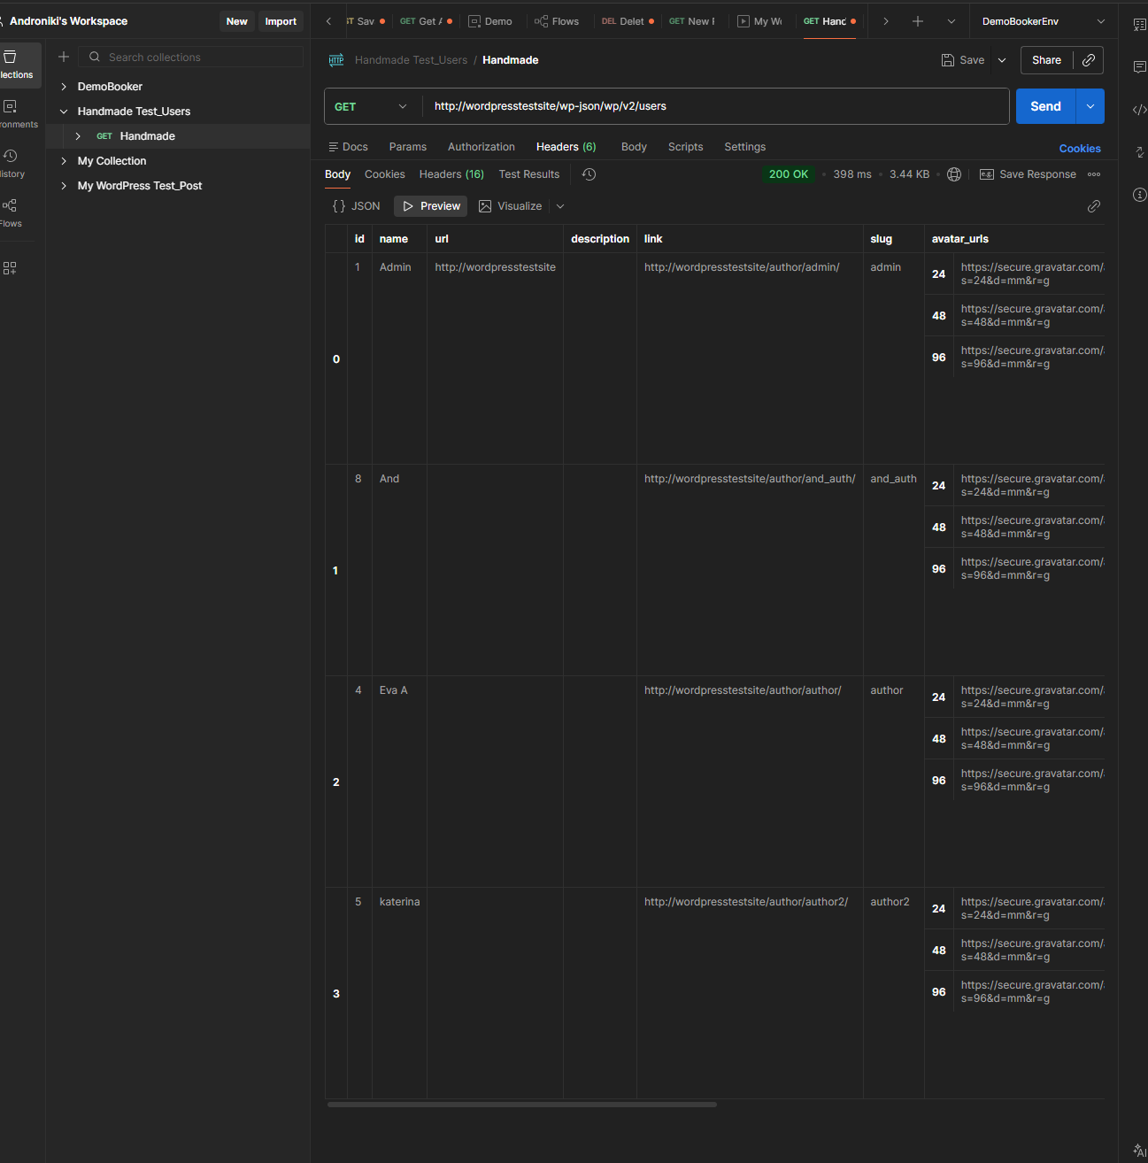 Successful Manual API Verification (Users Endpoint - 200 OK)

Firefox
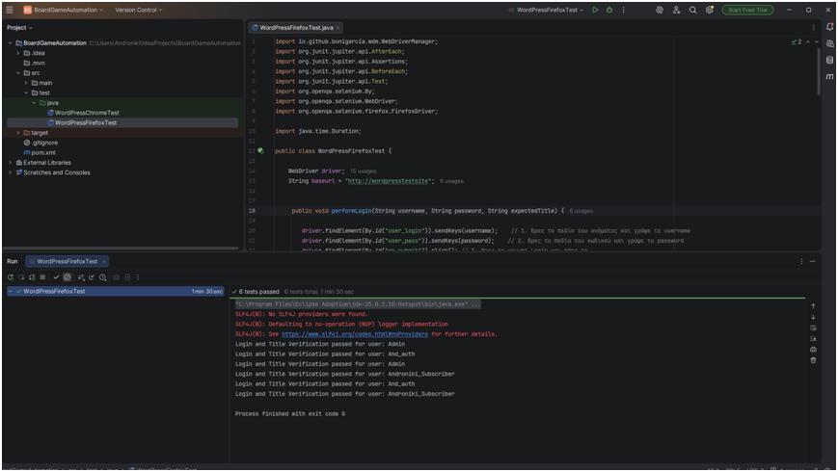
Chrome:
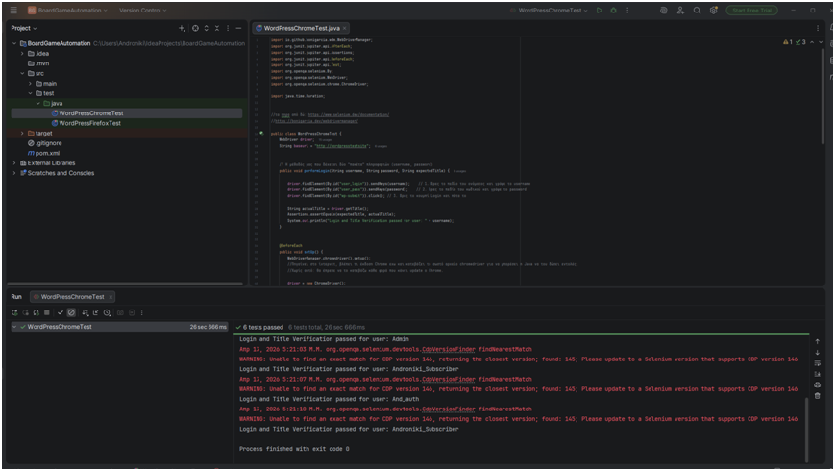

- What to automate first (priority list):
High Priority:
- User login
- Navigation validation
- Search functionality (including no result behavior)
- Post opening (Continue reading flow)
- Comment submission
- Basic API checks
Medium priority:
- Comment moderation scenarios
- Role-based validation (Author vs Admin behavior)
- Basic responsive checks

- What NOT to automate (and why):
- Frequently changing content (post list)
- Detailed visual / UI validation
- Database repair scenarios
- Complex role/ permission investigation scenarios
Automation focuses on stable, repeatable and high frequency scenarios. More complex or environment dependent scenarios are better suited for manual testing
4. Framework & Standards
- Tool:
- UI Automation: Selenium WebDriver (Java) + JUnit 5.
- API Testing: Postman (Collections & Environments).
- Manual Testing: Browser DevTools & Manual Exploratory Testing.

- Design pattern:
The automation code follows a Method Extraction and Refactoring approach
- Naming conventions:
- Selenium: camelCase ( e.g. adminLoginTest)
- Postman: descriptive naming (e.g. GET - Log in / Admin).

- Selector policy:
- Prefer stable selectors (IDs, consistent classes)
- Avoid dynamic or fragile selectors
- Special focus on admin UI stability
- Reporting & logs:
- Screenshots on failure
- Logs for debugging
- Simple reports for test results

5. CI/CD Execution Plan
- Triggers:
- On every change – run basic tests
- Nightly – run more complete tests
- Before release – run full test suite
- Parallel strategy:
- Separate smoke and regression tests
- Group tests by functionality (login, posts, users, comments)
- Run tests in parallel if possible
- Flaky test policy:
- Identify unstable tests
- Temporarily remove them
- Fix them before adding them back
6. Maintenance Plan
- Test refactoring:
- Update tests when something changes in the application
- Review tests when user management or post functionality changes
- Improve tests over time for better stability
- Ownership:
- Assign responsibility for maintaining tests
- QA and developers should collaborate
- Versioning & branching strategy:
- Keep tests aligned with code changes
- Use branches for better organization

